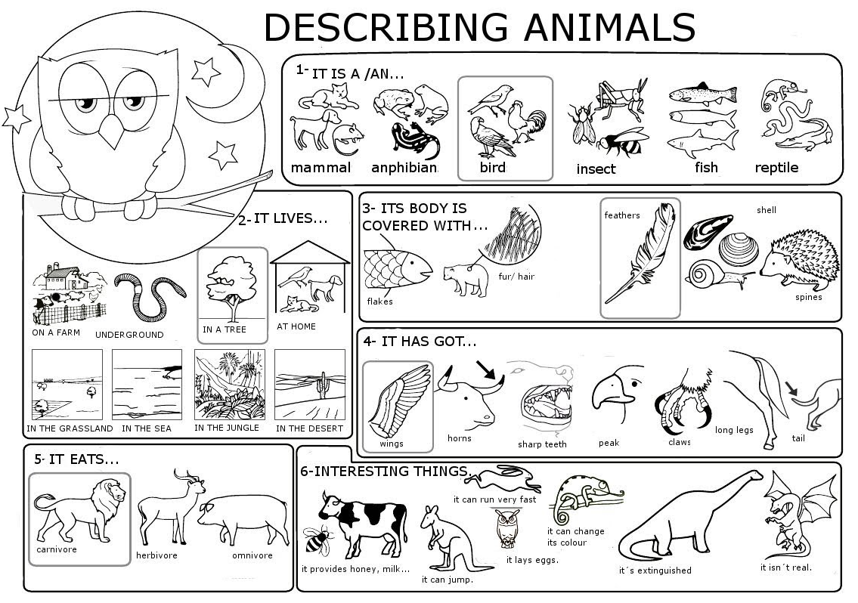
LION | GIRAFFE | HORSE | SWAN
RABBIT / HARE | MONKEY | LIZARD | BEE
COW | TURTLE | ELEPHANT | SPIDER
PARROT | DOLPHIN | SHARK | BEAR
