Zadání 6 4.5.- 8.5. 2020

- Podle receptu vytvoř „Košík z vejce“, postupuj podle návodu (pošli obrázek výtvoru - košíku)
- Místo tvoření si můžeš zvolit druhou možnost – přelož recept (suroviny + postup) do českého jazyka – napiš do sešitu a ofocené pošli.

--------------------------------------------------------------------------------------------------------------------------------------

Egg basket
Ingredient: 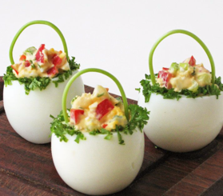
1-2 eggs
1/4 red bell pepper
1 piece of radish
1 spring onions
chive
parsley greens
salt
freshly ground pepper
1 tablespoon of mayonnaise
parsley stalks for serving

Boil the eggs hard for about 10-12 minutes, then let cold water on them and clean them.
Cut the peppers, radishes, onions into small cubes, chop the chives and parsley greens, set aside 2 teaspoons of the latter.
We cut off the top of the eggs, carefully take out the yolks as well, then we dice them, we crush them, and we mix them with the vegetables.
Add the whole salt, pepper and mix with a little mayonnaise until creamy.
The edge of the egg baskets is watered in and then pressed into the chopped parsley green. Fill them with egg custard and make ears of curved parsley stalks for them.
Keep in the refrigerator until served, covered with foil.

